BANNING THE BOMB:
WHICH SIDE ARE WE ON?

CANADA’S NUCLEAR MOMENT OF TRUTH
AT THE UNITED NATIONS

Information Session and Discussion

Monday, September 26, 12:00-2:00 P.M.

Sydney Credit Union Room (CE265), Cape Breton University

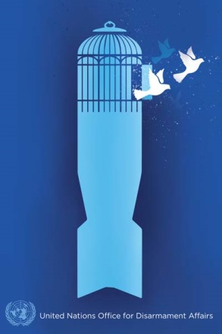

For more information, please contact Sean Howard, Adjunct Professor of Political Science, Cape Breton University, at sean_howard@cbu.ca or 902-563-1468.

